Nama : Jefri Haris Laksmana  
NIM : 18090025  
Kelas : 5D

Laporan Praktikum 5

1. Source Code

matakuliahvalidation.php -> application/controllers/

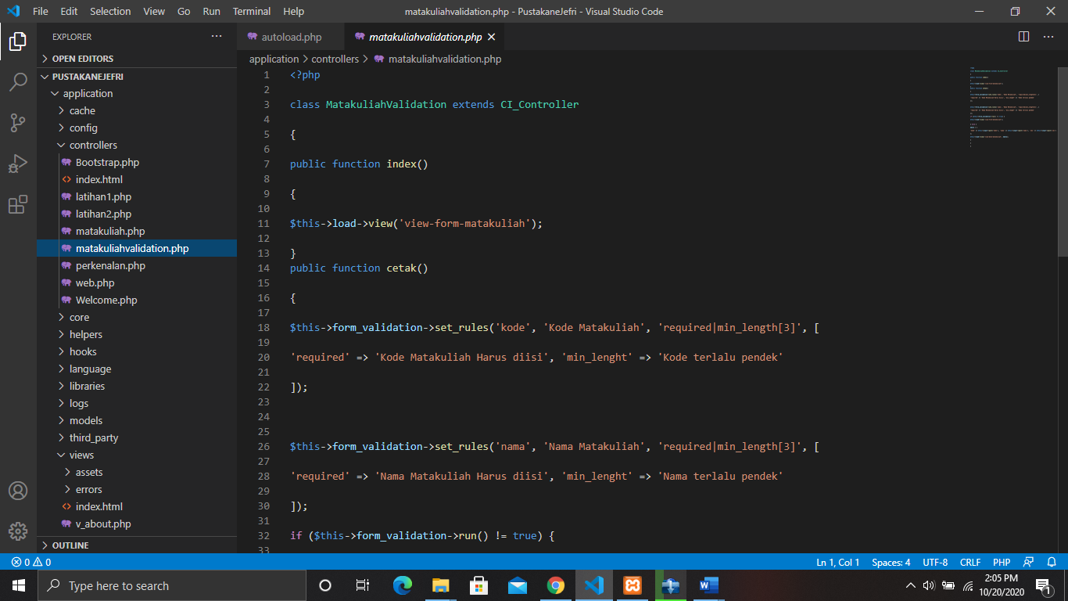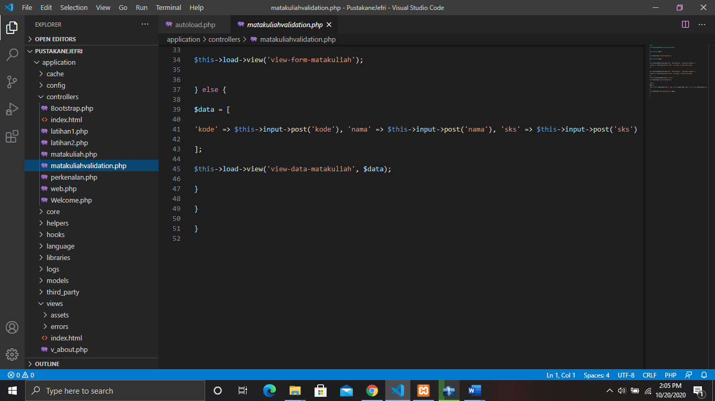

autoload.php -> application/config/

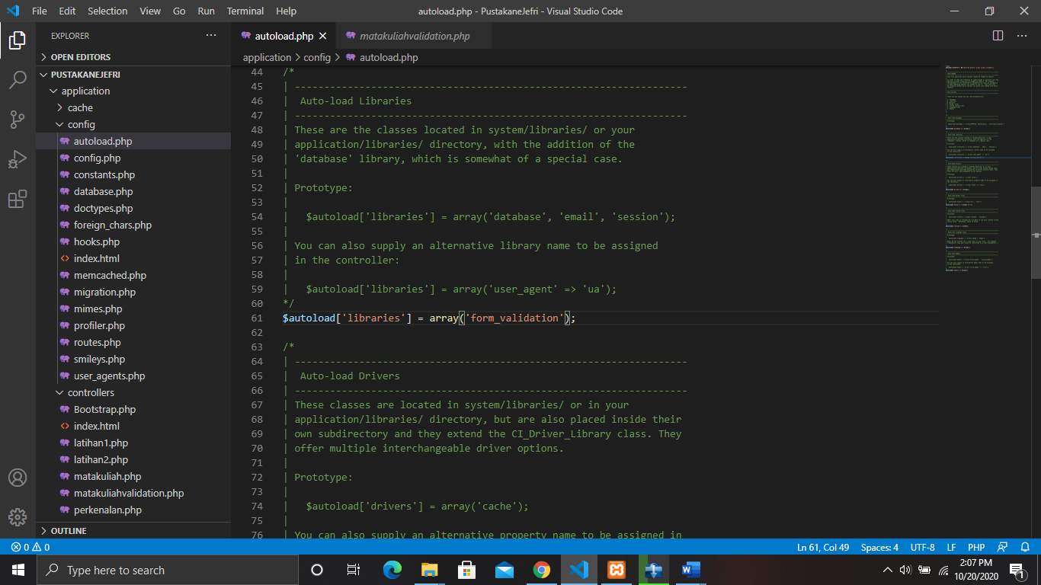

1. URL

<http://localhost/PustakaneJefri/matakuliahvalidation>

1. Capture Output Program

